KIDS NIGHT OUT 2019-2020

5:00PM-9:00PM
September 14th  October 12th  November 9th | December 7th  January 11th  February 15th | March 7th  April 11th  May 9th  & June 13th
Kids Night Out is a fun and exciting way for your child to spend their Saturday night. Sunburst Gymnastics is giving you the opportunity to drop your kids off for dinner, gymnastics, arts-n-crafts, sports games, recreational games and movie time! While you enjoy a few hours off!

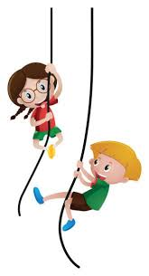
- We supply pizza & drinks
- Arts & Crafts
- Movies
- Trampoline
- Tumble Track
- Spaceball
- Trampoline Basketball
- Jump the Sock
- Relay races
- Hide & Go Seek
- Gymnastics
- Rope Swing (Tarzan)
- Rock Wall
- Cargo Net
- …and MORE!
Pricing: Member $30 / Non-Member $35
CASH ONLY

Pre-registration is required. Sign-Up Early! Limited number of spots available!

All children attending Kids Night Out MUST be 5 years of age or older.

For more information please contact the office @ 908-810-1300 or info@sunburstnj.com

